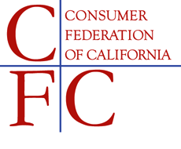
1107 9th Street, Suite 625 • Sacramento, CA 95814 • (916) 498-9608 • mail@consumercal.org

May 31, 2017

ASSEMBLY FLOOR ALERT
AB 713 (Chu) – SUPPORT

The Consumer Federation of California (CFC) supports AB 713 (Chu), which would ensure that residents of a Continuing Care Retirement Community (CCRC) have the ability to prompt a fair and adequate review of an involuntary transfer of care.

Specifically, AB 713 strengthens current law by requiring CCRC providers to conduct an assessment of the resident to help better identify the necessity and appropriateness of the initiated transfer. This bill also requires the department to consider the assessment as a tool to justify the transfer when it is disputed. Any transfer of care, or change in living environment, places stress on an aging senior. Therefore, transfers should be handled with the utmost care and only when it is medically necessary and in the best interest of the senior.

Under current law, the resident’s right to dispute a transfer is meaningless. Without a requirement for the department to consider the residents health, physical and cognitive abilities any review is simply a look at whether or not a provider gave adequate notification and followed other procedures. It does not indicate whether a transfer of care, which has significant financial and health impacts, is necessary or appropriate.

As the regulatory body, the department has no financial interest in the residents transfer, and therefore they are the most appropriate body to consider whether or not the assessment, conducted by the provider, also justifies a need for the residents transfer.

We urge your “Aye” vote on AB 713.

