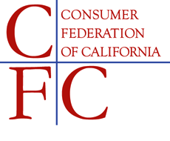
1107 9th Street, Suite 625 • Sacramento, CA 95814 • (916) 498-9608 • mail@consumercal.org

September 5, 2017

ASSEMBLY FLOOR ALERT
SB 63 (Jackson) – SUPPORT

The Consumer Federation of California (CFC) supports Senate Bill 63 (Jackson).

This bill ensures that more California workers, who have been paying into the Paid Family Leave insurance program, are able to use this benefit without the risk of losing their job.

Research has shown that when parents are able to stay home and care for their newborn and young children there are significant benefits to the health and wellbeing of the child. In fact, 80% of the child’s total bran development happens in the first three years, and parent-child interactions in the first three months are key to establishing the foundation for success. Under current law, only those Californians’ who work for an employer of 50 or more are eligible for job-protected parental leave. This leaves too many new parents struggling with the impossible choice between the well-being of their child and their financial security.

SB 63 would extend eligibility for job-protected parental leave to employees who work for a company with 20 or more employees; benefiting up to 2.7 million more Californians, but only affecting 6 percent of the businesses.

CFC urges your “Aye” vote on SB 63.

